Automate Business Process Flow (BPF) Stage Movement Using Power Automate
Below is the complete step-by-step procedure to move a BPF stage automatically based on conditions (example: Opportunity BPF → Opportunity Sales Process).

🔵 STEP 1 — Identify the BPF Entity Behind the Process
Every BPF in Dynamics 365 has an underlying table.
For the Opportunity Sales Process, the table is:
Item | Value
BPF Entity | opportunitysalesprocess
Key Fields | activestageid, statuscode, _bpf_opportunity_value, processid
You will use this entity to read & update the BPF instance.

🔵 STEP 2 — Create a New Power Automate Cloud Flow
- Open Power Automate
- Click Create
- Select Automated Cloud Flow
- Give the flow a name → e.g., Automate Opportunity BPF Stage
- Set the trigger → continue

🔵 STEP 3 — Select the Trigger
Choose:
Trigger:
➡️ When a row is added, modified or deleted (Dataverse)
Configure it:
- Table: Opportunity (opportunity)
- Scope: Organization
- Change Type: Modified (recommended)
Optional: Add a trigger condition later to avoid unnecessary runs.

🔵 STEP 4 — Add a Condition
Example condition:
Move BPF stage only when Estimated Revenue > 50,000
In the Condition:
- Left value: estimatedvalue
- Operator: greater than
- Right value: 50000
If Yes → proceed to next steps.
If No → do nothing.

🔵 STEP 5 — Get BPF Instance (List Rows)
Add List Rows (Dataverse).
Purpose: fetch the BPF instance linked to this Opportunity.
Configure:
- Table: opportunitysalesprocess
Filter Query:
_bpf_opportunity_value eq @{triggerOutputs()?['body/opportunityid']}
This retrieves the active BPF instance for the Opportunity.
From this List Rows, you will later use:
- opportunitysalesprocessid → BPF Instance ID
- _processid_value → BPF Definition ID

🔵 STEP 6 — Get the Target Stage (ProcessStage Table)
You cannot directly set activestageid with text.
You MUST provide the processstageid.
So add:
➕ List Rows (Dataverse)
- Table: Process Stages (processstage)
Use this filter:
_processid_value eq @{first(outputs('List_BPF')?['body/value'])?['_processid_value']}
and stagename eq 'Develop'
Replace 'Develop' with the stage you want (e.g., Propose, Close).
From this output, capture:
- processstageid → required to update activestageid

🔵 STEP 7 — Update the BPF Record (Move to New Stage)
Add: Update a row (Dataverse)
Configure:
- Table: opportunitysalesprocess
- Row ID:
@{first(outputs('List_BPF')?['body/value'])?['opportunitysalesprocessid']}
Now set:
Field | Value
activestageid | processstageid from Step 6
Power Automate will automatically map the stage reference.

🔵 STEP 8 — Save and Test
- Open an Opportunity record
- Change Estimated Revenue to 60,000
- Click Save
- Power Automate runs
- BPF Stage moves from: Qualify → Develop (or whichever you set)

Short + strongest points:
🔵 1. Plugins cannot reliably update BPF stages
- BPF runs in a separate async pipeline, plugins run in the main pipeline → conflicts.
- Updating activestageid via plugin can cause errors.
➡ Microsoft does NOT recommend plugins for BPF automation.
🔵 2. JavaScript cannot update backend BPF data
- JS runs only on UI, not server.
- Cannot modify processstage, opportunitysalesprocess tables.
➡ JS is not capable of changing BPF stages safely.
🔵 3. Power Automate natively
- Can read processstage, BPF instance, and update activestageid.
- Dataverse connector is built for this.

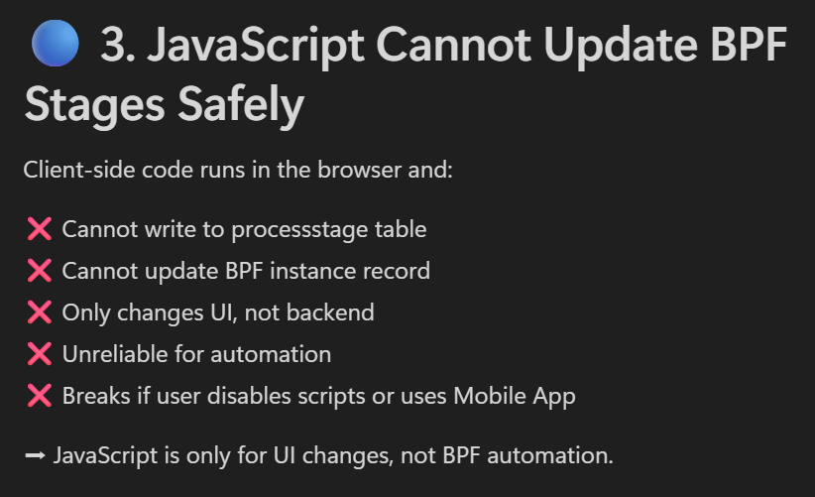

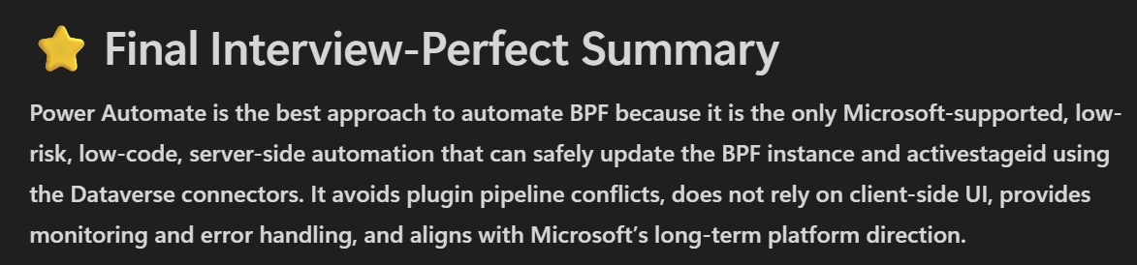
Only One Active BPF per Record
A record (like Opportunity, Case, Lead) can have only one active BPF at a time.
You cannot run multiple BPFs simultaneously on the same record.

2. Limited to Stage-Based, Linear Processes
BPFs cannot handle:
- Complex branching logic
- Dynamic looping
- Non-linear workflows
They follow a fixed, sequential stage flow, which is a limitation for complex business scenarios.

3. Cannot Perform Server-Side Logic Directly
BPF cannot:
- Update fields automatically
- Create records
- Call APIs
- Run server-side logic
For automation, you must use:
- Power Automate
- Workflows
- Plugins
BPF alone is only a visual guidance tool.

⭐ Extra (If needed)
Other limitations:
- Maximum 30 stages
- Maximum 5 BPFs can be switched per entity
- Cannot handle heavy data processing
- Limited custom controls / UI capabilities

Connection and connection reference
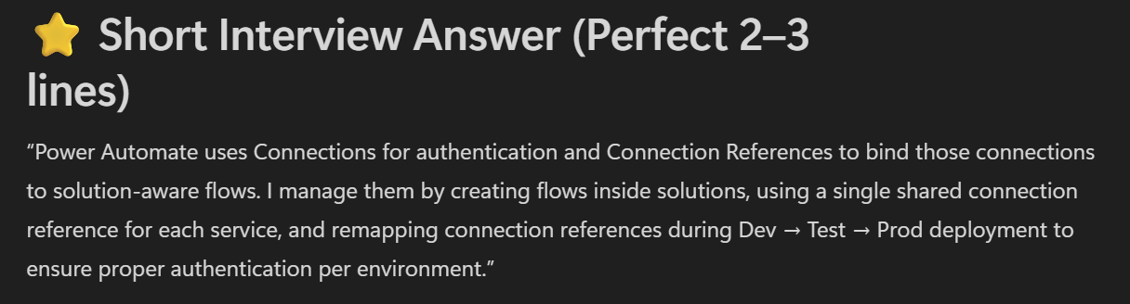

Notepad notes =>

Data operations
02 June 2025
15:41

Create csv table -

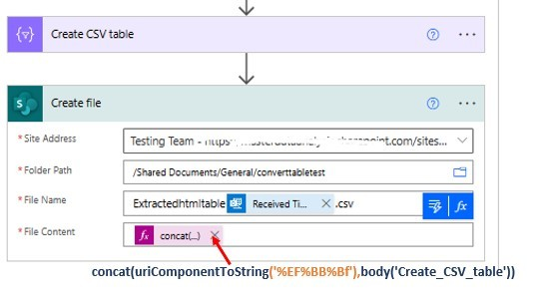

In body while taking it expects array so
e.g:body('List_of_products')?['value']

Output - Array of objects

. Compose
Used to store or calculate a value.
✔ Hold temporary data
✔ Use expressions
✔ Pass data between steps

🔵 2. Parse JSON
Used to read structured data from:
- API responses
- Webhooks
- HTTP calls
- Power Apps inputs
✔ Creates dynamic tokens
✔ Strongly recommended for APIs

🔵 3. Create HTML Table
Converts array → HTML table.
Used for:
- Emails
- Reports
- Approvals

🔵 4. Create CSV Table
Converts array → CSV format.
Used in:
- File exports
- Integration with Blob/OneDrive
- Data migration

🔵 5. Join
Combines an array into a single string with a separator.
Example:
Join email addresses with ;

🔵 6. Select
Transforms each item in an array.
✔ Useful for mapping fields
✔ Reshape JSON for API calls
Example:
Convert complex object → simple array.

🔵 7. Filter Array
Filters items based on conditions.
✔ Used heavily in Dataverse list row filtering
✔ Example: Get active cases only

🔵 8. Append to Array Variable
Adds data into an existing array.
Used in loops to build collections.

🔵 9. Append to String Variable
Adds text to a string variable.
Used for logs or combined messages.

🔵 10. Initialize Variable / Set Variable

1. JOIN (Data Operation)
Purpose:
Used to convert an array into a single string using a separator.
Where used:
- Combine multiple values into one line
- Build comma-separated or semicolon-separated lists
- Prepare text for emails, logs, or API calls
Example:
Array:
["Onkar", "Riddhi", "Gopal"]
Join with comma:
join(body('List_rows')?['value'],' , ')
Output:
Onkar , Riddhi , Gopal

2.
Suppose you have JSON like this:

JSON
{
"name": "Onkar",
"city": "Pune",
"age": 25
}

Show more lines
This JSON comes from:
- API response
- HTTP call
- Webhook
- Custom connector
Power Automate does NOT understand these values directly.
So we use Parse JSON.

🔵 Step 1: Add Parse JSON Action
Inside Parse JSON:
Content:
Paste the JSON body (dynamic content).
Schema:
Click Generate from sample
Paste the same JSON:

JSON
{
"name": "Onkar",
"city": "Pune",
"age": 25
}
Show more lines
Power Automate creates schema automatically.

Output After Parse JSON
Now Power Automate gives you dynamic fields:
- name
- city
- age
You can directly use them anywhere.
Example:
- In email → "Hello @{body('Parse_JSON')?['name']}"
- In Dataverse → map name field
- In Condition → age > 18

Difference between item() and items ()
- item () = current row inside a loop
Used inside a loop
This refers to the current record/object inside actions like:
  - Apply to each
  - Select
  - Filter array
  - Compose inside a loop

- items() = item from a specific scope/loop name
Normally used when:
- You need the value of the entire trigger body
- You need the object of an outer loop from inside an inner loop
- You need to reference another loop's item

Difference between body and item
1. body
body = the entire output of an action.
When you run any action (List rows, Get row, HTTP request), Power Automate stores the full JSON response under:
body('ActionName')
This contains all properties returned by that action, including metadata, paging info, count, and the actual data.
Example:
body('List_rows')
This returns the whole JSON object:
JSON
{
"@odata.context": "...",
"value": [ ... ],
"@odata.nextLink": "...",
"total": 25
}
Show more lines

✅ 2. value
value = the actual list of records inside the body.
Most Dataverse List rows or HTTP GET responses include an array named value containing the rows.
So:
body('List_rows')?['value']
This returns only:
JSON
[
{ record1 fields… },
{ record2 fields… },
...
]
Show more lines
This is what you use inside:
- Apply to each
- Filter array
- Select

🧪 Example: Dataverse List Rows (Documented Behavior)
Microsoft Learn confirms that OData responses return table rows inside a value array, not directly in the body.
[powerplatf...mspace.com]
So:
- body() → entire JSON, including metadata
- value → only the records array

🧩 Simple analogy
Term | Meaning
body | The whole box
value | The items inside the box

Connection And Connection Reference
02 June 2025
16:51

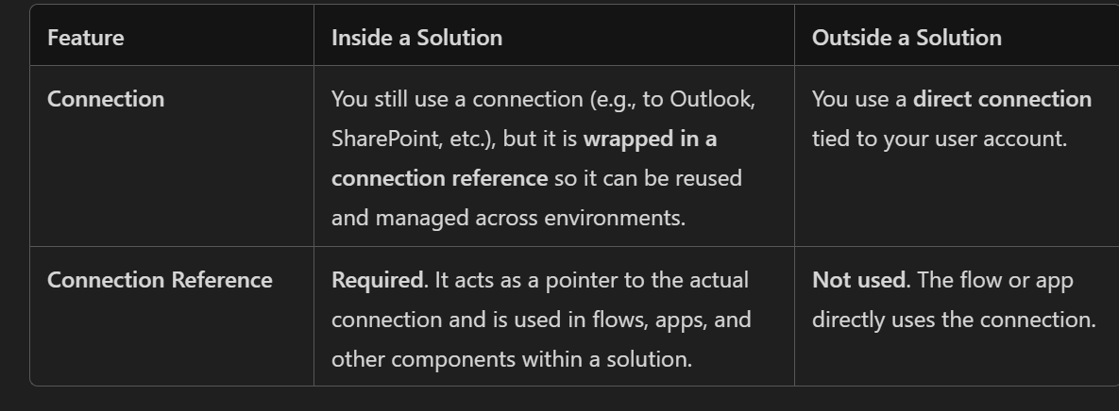
Inside a solution: You use Connection References (which point to actual Connections)
Outside a solution: You use Connections directly (no reference layer).

  - A Connection is user/environment specific.
  - A Connection Reference is a placeholder inside the solution that points to a connection at runtime.

What Is a Connection Reference? (Very Important)
A Connection Reference is a pointer to a connection used inside a Solution.
It is required for: ✔ Moving solutions from Dev → Test → Prod
✔ ALM (Application Lifecycle Management)
When importing a solution, you only map:
  - Same connection reference
→ to a new connection in that environment

What a Connection Contains
A Connection contains:
Item | Meaning
Connector | Which system (Dataverse, SharePoint, API)
Credentials | Username/password/API key
Token | Used for authentication
Permissions | What the flow can do
Owner | Who created the connection

  - Cannot add the connection reference for this types of actions -

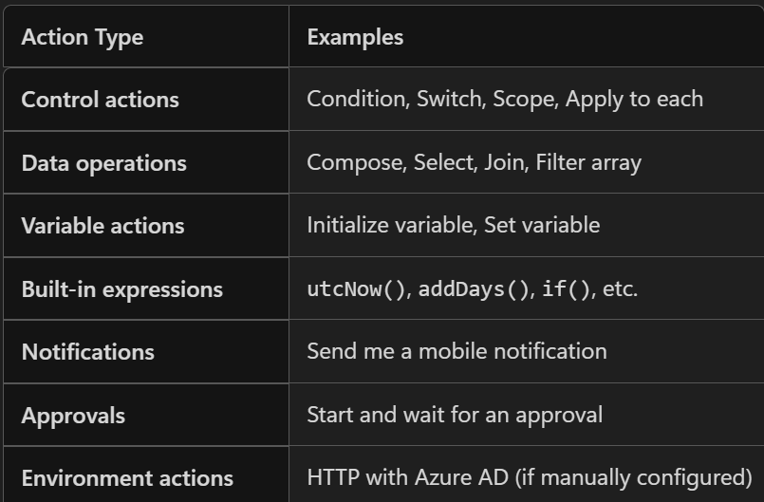

Authentication Types in Power Automate
  - OAuth Authentication
  - Purpose: Used for single-user scenarios.
  - Mechanism: Authenticates using the user's credentials.
  - Behavior: The flow runs under the identity of the user who created or is assigned to it.
  - Use Case: Ideal for flows that perform actions on behalf of a specific user.
  - ✅ Example: A flow that sends emails from a user's Outlook account or updates records in Dataverse using the user's permissions.

2. Service Principal Authentication
  - Purpose: Used for unattended or background flows.
  - Mechanism: Authenticates using an Azure AD app registration (Client ID + Secret).
  - Behavior: The flow runs using the Service Principal, not a user account.
  - Use Case: Ideal for server-to-server communication or automation without user interaction.
✅ Example: Your organization wants to automate the creation of invoice records in Dataverse whenever a new order is placed in an external ERP system. The flow runs securely in the background using a Service Principal.

  - Client Certificate Authentication
  - Purpose: Used for high-security integrations, especially with external systems.
  - Mechanism: Authenticates using a digital certificate instead of a password or secret.
  - Behavior: Ensures secure, passwordless authentication that meets MFA requirements.
  - Use Case: Ideal for secure API calls, especially in regulated environments.
✅ Example: A Power Automate flow sends data to a government tax portal via a secure API. The portal requires client certificate authentication to ensure compliance and security. You obtain a certificate from the government authority and use it in the flow.
Retry Policy
25 August 2025
11:00

Whenever we are creating a flow, we might have encountered that a connector keeps sporadically failing due to some request issues or server-side errors in which the server fails to fulfil an apparently valid request. We can fortunately tackle these issues by setting up the retry policy for the connector. A retry policy applies to intermittent failures, characterized as HTTP status codes 408, 429, and 5xx, in addition to any connectivity exceptions. The default is an exponential interval policy set to retry 4 times. It is a good practice to set a retry policy for sending http requests and for Create, Update, Delete actions for Dataverse or any other service like SharePoint or SQL.
A retry policy automatically re-attempts a failed action based on a defined strategy. This helps improve the reliability of your flows without manual intervention.

Error Code | Description
408 | Request Timeout
429 | Too many requests
5xx | 500 – Internal Server Error  503 – Service Unavailable  522 – Connection timed out, etc.

Retry Policy | Description
Default | The default is an exponential interval policy set to retry 4 times.
None | Do not retry if failed.
Fixed Interval | Count - Number of times to retry  Interval - Time between retries.
Exponential Interval | Count - Number of times to retry  Interval - Time between retries  Minimum and Maximum Interval - the retry will happen exponentially (Increase or decrease) between the specified intervals.

What is exponential interval
Exponential Backoff Explained
The delay between retries increases exponentially. For example:

Retry 1: Wait 5 seconds
Retry 2: Wait 10 seconds
Retry 3: Wait 20 seconds
Retry 4: Wait 40 seconds
Retry 5: Wait 80 seconds
This pattern helps reduce the load on the failing service and increases the chance of success.

When to use the retry policy ---->

Using Connectors Prone to Throttling

Services like SharePoint, Outlook, or SQL may throttle requests if limits are exceeded. Retry can help wait and reattempt after a short delay.

Network-Dependent Actions

HTTP requests, cloud storage access, or any internet-based service may fail due to network issues.
Retry ensures resilience against such transient failures.

Long-Running or Delayed Responses
If a service takes longer than expected to respond, retry can help avoid premature failure.

E.g --
Fixed interval
- Count: 3
Interval: 30 seconds
→ Retries at 30s, 60s, 90s

- Exponential interval
Count: 4
Interval: 5 seconds
→ Retries at 5s, 10s, 20s, 40s

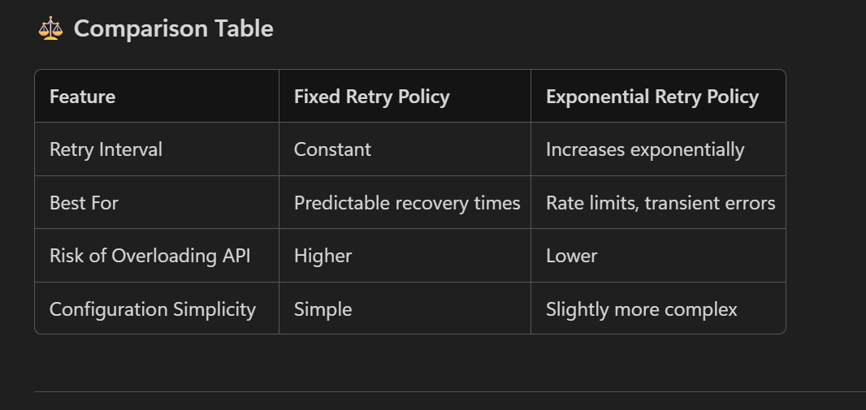

Refer this -
https://imperiumdynamics.com/blog/Power-Automate-Retry-and-Timeout-Policy.html

Concurrency Control
25 August 2025
12:22

Concurrency control in Power Automate refers to the mechanism that allows multiple runs or loops of a Flow to run at the same time.

Refer this -
https://www.beringer.net/beringerblog/advantages-of-concurrency-control-in-power-automate/

https://manueltgomes.com/microsoft/what-is-concurrency-control/

What is Concurrency Control in Power Automate (for Dynamics 365 CRM)?
Concurrency Control in Power Automate is used to control how many flow runs execute in parallel for a trigger or loop.

🔵 Why It Is Used in Dynamics 365 CRM?
In CRM, multiple users can update the same record at the same time.
Without concurrency control:
- Multiple flow runs may trigger simultaneously
- They may try to update the same CRM record
- This can cause: ✔ Duplicate updates
✔ Wrong BPF stage movement
✔ Race conditions
✔ Data inconsistency
Concurrency control prevents this.

🔵 What It Does?
✔ 1. Prevents parallel execution
You can set:
- Degree of Parallelism = 1 → Only one run at a time (FIFO queue)
This is the most common setting for CRM.
✔ 2. Ensures correct data updates
When updating:
- Opportunities
- Cases
- Work Orders
- BPF stages
You avoid conflicts.
✔ 3. Avoids race conditions
Two flows updating the same field → only one runs at a time.

🔵 Where Is It Used?
1. Trigger Level Concurrency Control
Used when:
- Flow triggers multiple times on the same record
You set:
- Turn on concurrency → OFF
or
- Set parallelism = 1
2. Within Loops (Apply to Each)
Prevent loops from running in parallel when updating multiple CRM records.

⭐ Short Interview Answer
“Concurrency control in Power Automate ensures flows do not run in parallel. We use it in Dynamics 365 CRM to avoid race conditions, prevent multiple simultaneous updates on the same record, and maintain data consistency—especially for triggers and loops. Setting concurrency to 1 guarantees sequential, safe execution.”

Empty vs Equals
26 August 2025
17:50

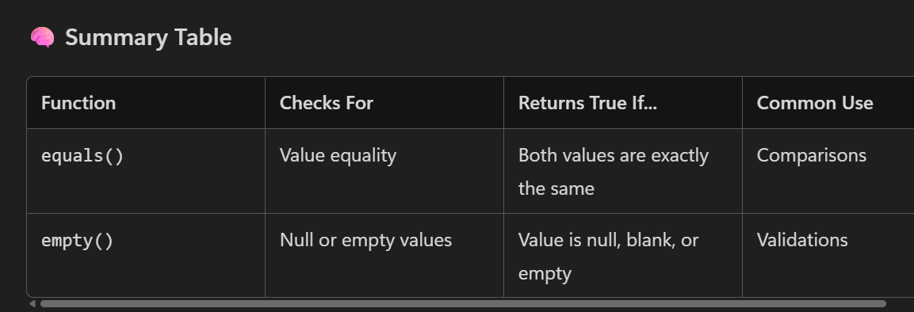

Use equals() function for direct handling of dynamic values and empty() for initialized string variables as PA converts the null string variables into "".

Refer this -

https://community.dynamics.com/blogs/post/?postid=a17b738a-142b-435f-8b91-3d2ba682d841

Fetch Expression
24 September 2025
18:24

length(body('Get_a_row_by_ID')) vs length(outputs('List_rows')?['body/value'])

- Get_a_row_by_ID - Return the single object
- List_rows - Return the array of object (rows)

-length(body('Get_a_row_by_ID')) - used for single row or object
- length(outputs('List_rows')?['body/value'] - used for array of objects

Looping in power automate
24 December 2025
15:21

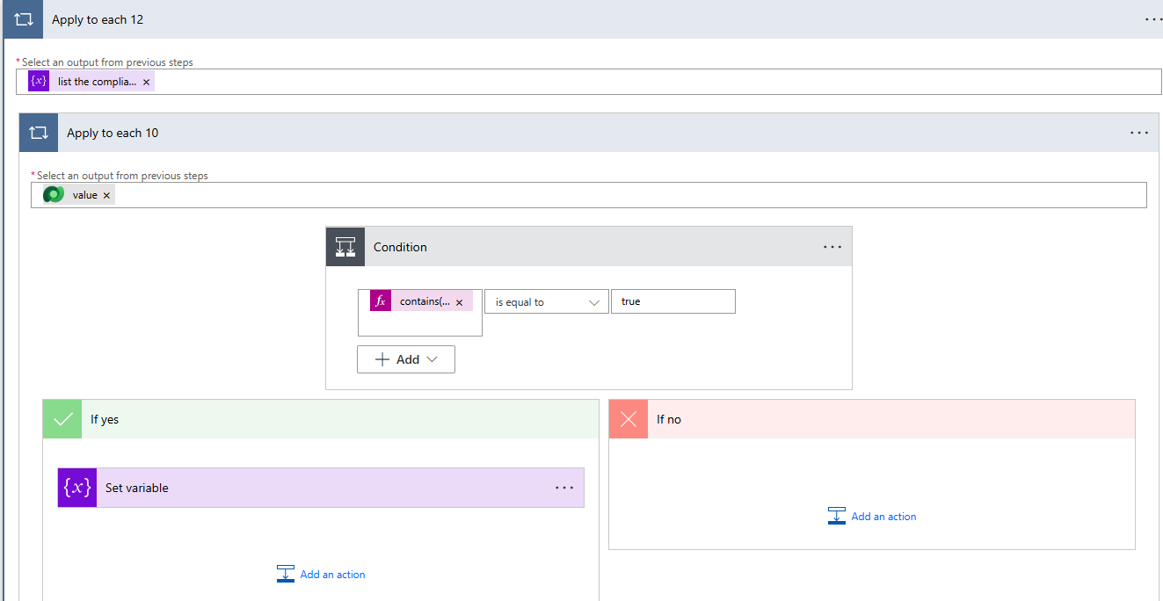

Many to many relationship fetch xml
24 December 2025
18:31

<fetch version="1.0" output-format="xml-platform" mapping="logical" distinct="true">
<entity name="nsq_compliance">
<!-- Select base-entity attributes only to allow DISTINCT to work correctly -->
<attribute name="nsq_complianceid"/>
<attribute name="nsq_name"/>
<order attribute="nsq_name" descending="false"/>

<!-- INCIDENT TYPE (N:N) -->
<link-entity name="nsq_compliance_msdyn_incidenttype"
from="nsq_complianceid" to="nsq_complianceid"
intersect="true" link-type="outer" visible="false" alias="jit">
<filter>
<condition attribute="msdyn_incidenttypeid" operator="eq"
value="@{triggerOutputs()?['body/_msdyn_primaryincidenttype_value']}" />
</filter>
</link-entity>

<!-- CUSTOMER ASSET (N:N) -->
<link-entity name="nsq_compliance_msdyn_customerasset"
from="nsq_complianceid" to="nsq_complianceid"
intersect="true" link-type="outer" visible="false" alias="jca">
<filter>
<condition attribute="msdyn_customerassetid" operator="eq"
value="@{triggerOutputs()?['body/_msdyn_customerasset_value']}" />
</filter>
</link-entity>

<!-- FUNCTIONAL LOCATION (N:N) -->
<link-entity name="nsq_compliance_msdyn_functionallocation"
from="nsq_complianceid" to="nsq_complianceid"
intersect="true" link-type="outer" visible="false" alias="jfl">
<filter>
<condition attribute="msdyn_functionallocationid" operator="eq"
value="@{triggerOutputs()?['body/_msdyn_functionallocation_value']}" />
</filter>
</link-entity>

<!-- Require that at least one of the three links exists (exclude unlinked compliances) -->
<filter type="or">
<condition entityname="jit" attribute="msdyn_incidenttypeid" operator="not-null"/>
<condition entityname="jca" attribute="msdyn_customerassetid" operator="not-null"/>
<condition entityname="jfl" attribute="msdyn_functionallocationid" operator="not-null"/>
</filter>
</entity>
</fetch>

Data operations
11 February 2026
10:52

- Filter rows based on the lookup value =>
_msdyn_workorder_value eq @{triggerBody()?['_msdyn_workordertype_value']}

Creating the URL for record navigation
11 February 2026
18:53

To create the url required parameters are
  - Environment url -

Option 1 -
  - Get the dynamic url of the environment
Whenever, we use Get Record action for any entity, you might have noticed one of the fields is ODate Id which actually stores the oData record URL of respective entity. We then parse this URL, to retrieve our tenant name.

  - uriHost(outputs('Get_a_record')?['body/@odata']?['id'])
  - This will fetch us null or empty output. There is a minor tweak to above expression:
  - uriHost(outputs('Get_a_record')?['body/@odata.id'])

Option 2 -
  - Environment variable

  - Appid -

Option1 -
  - Use the environment variable

Option 2 -
  - Retrieve appid using List Records action to query on Model Driven App entity

  - 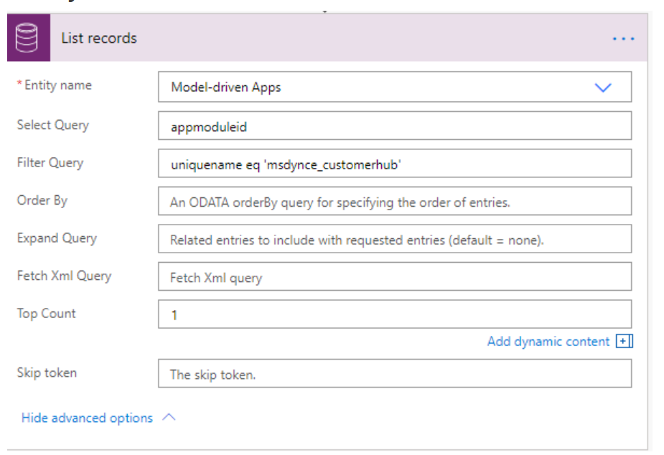

In the filter, enter the unique name of your app and the attribute app moduleid fetches you the GUID of app. Remember to enter top count to 1 thereby fetching only one record

  - Page Type -

'&pagetype=entityrecord&etn=entityname

  - Retrieve the account entity GUID Dynamically

  - &id=entity id

Result -

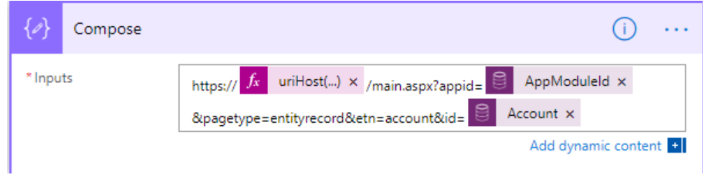

Refer -MS POWER AUTOMATE/FLOW: HOW TO CONSTRUCT DYNAMIC RECORD URL AND SEND AN EMAIL FROM DYNAMICS 365/CDS

Example concat
concat(
'<a href="',
'https://',
uriHost(outputs('Get_a_row_by_ID')?['body/@odata.id']),
'/main.aspx?appid=',
first(outputs('List_rows')?['body/value'])?['appmoduleid'],
'&pagetype=entityrecord&etn=account&id=',
outputs('Get_a_row_by_ID')?['body/accountid'],
'">Click here</a>'
)

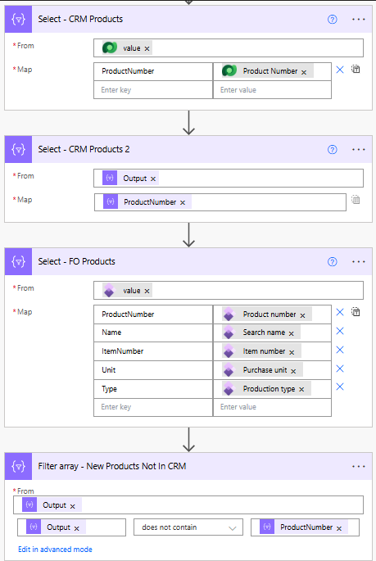

Power Automate Scenarios I have Worked On

1.Business events and workflow approvals
Reference Link -
https://learn.microsoft.com/en-us/dynamics365/fin-ops-core/dev-itpro/business-events/how-to/how-to-workflow

